AGAPE INSPECTION MANAGEMENT SERVICE

Inspection Report
Property Address:
xxxxxxx
Xxxxxx, xx
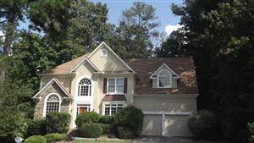

Agape Inspection Management Service Inc.
1-800-681-2467
Top Table of Contents Bottom

Table of Contents
- Cover Page
- Table of Contents
- Intro Page
- 1 Roofing
- 2 Exterior
- 3 Garage
- 4 Interiors
- 5 Structural Components
- 6 Plumbing System
- 7 Electrical System
- 8 Heating / Central Air Conditioning
- 9 Insulation and Ventilation
- 10 Built-In Kitchen Appliances
- 11 Photo Library
- General Summary
- Invoice
- Agreement

Top Table of Contents Bottom

Date: 9/22/2012 | Time: 01:00 PM | Report ID: 4051899

Property:  302 Harbor Point Drive  Stone Mountain GA 30087 | Customer:  Mr. Abauljadir Ali | Real Estate Professional:  Martha Jackson  Solid Source Realty
Comment Key or Definitions
The following definitions of comment descriptions represent this inspection report. All comments by the inspector should be considered before purchasing this home. Any recommendations by the inspector to repair or replace suggests a second opinion or further inspection by a qualified contractor. All costs associated with further inspection fees and repair or replacement of item, component or unit should be considered before you purchase the property.
Inspected (IN) = I visually observed the item, component or unit and if no other comments were made then it appeared to be functioning as intended allowing for normal wear and tear.
Not Inspected (NI)= I did not inspect this item, component or unit and made no representations of whether or not it was functioning as intended and will state a reason for not inspecting.
Not Present (NP) = This item, component or unit is not in this home or building.
Repair or Replace (RR) = The item, component or unit is not functioning as intended, or needs further inspection by a qualified contractor. Items, components or units that can be repaired to satisfactory condition may not need replacement.
In Attendance:  Customer and their agent | Type of Dwelling:  Single Family (2 story) | Approximate age of building:  Over 10 Years
Temperature:  Over 65 | Weather:  Clear | Ground/Soil surface condition:  Dry
Rain in last 3 days:  No | Was a Radon Test performed?:  No | Was a Water Test performed?:  Yes
Was water on at time of inspection?:  Yes | Was gas service on at time of inspection?:  Yes | Was Heat on during inspection?:  No
Was Air Conditioning on during inspection?:  Yes | Was Electricity on during inspection?:  Yes | Is this home New Construction?:  No
Was Oil for heat system on?:
Not oil - uses different source for heat

Top Table of Contents Bottom

Column Headers are designed to point out the inspectors' findings. INSPECTED (I) means that the inspector inspected that component and it appeared that it was functioning as intended. NOT INSPECTED (NI) means that the component was not inspected and no representations to the condition are made. NOT PRESENT (NP) means that the component was not in the home. MAINTENANCE REPAIR/REPLACE (MR) means repairs or service to the home that is typically found or associated with wear and time. These repairs are important and can progress or cause further damage if not corrected. MR repairs can often be performed by qualified people whose skill may not require a license. TRADESMAN REPAIR/REPLACE means that these repairs or further inspections should be performed by a qualified licensed or certified tradesman. NOTE: Any estimates given by the inspector are for NACA purposes only and are general price ranges. Estimates are inaccurate by nature and further inspection by a tradesman could reveal a more costly repair.
1. Roofing
The home inspector shall observe: Roof covering; Roof drainage systems; Flashings; Skylights, chimneys, and roof penetrations; and Signs of' leaks or abnormal condensation on building components. The home inspector shall: Describe the type of roof covering materials; and Report the methods used to observe the roofing. The home inspector is not required to: Walk on the roofing; or Observe attached accessories including but not limited to solar systems, antennae, and lightning arrestors.
IN NI NP RR  1.0 ROOF COVERINGS X  1.1 FLASHINGS X  1.2 SKYLIGHTS, CHIMNEYS AND ROOF PENETRATIONS X  1.3 ROOF DRAINAGE SYSTEMS X  IN NI NP RR  IN=Inspected, NI=Not Inspected, NP=Not Present, RR=Repair or Replace | Styles & Materials  Roof Covering:  Asphalt/Fiberglass  Viewed roof covering from:  Binoculars  Number of layers of roof covering:  Two  Estimated age of roof covering:  15 - 20 years  Sky Light(s):  None  Chimney (exterior):  Wood
Comments:

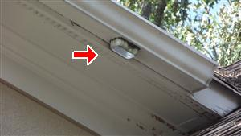  1.0 Missing Downspout | 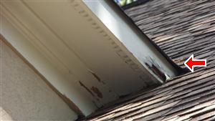  1.0 Damaged Soffit

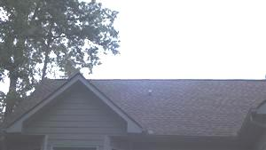
1.0 Front Roof
1.3 The right upper downspout is missing.
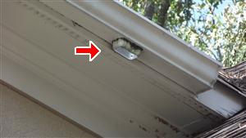
1.3 Missing Downspout
The roof of the home was inspected and reported on with the above information. While the inspector makes every effort to find all areas of concern, some areas can go unnoticed. Roof coverings and skylights can appear to be leak proof during inspection and weather conditions. Our inspection makes an attempt to find a leak but sometimes cannot. Please be aware that the inspector has your best interest in mind. Any repair items mentioned in this report should be considered before purchase. It is recommended that qualified contractors be used in your further inspection or repair issues as it relates to the comments in this inspection report.

Top Table of Contents Bottom

2. Exterior
The home inspector shall observe: Wall cladding, flashings, and trim; Entryway doors and a representative number of windows; Garage door operators; Decks, balconies, stoops, steps, areaways, porches and applicable railings; Eaves, soffits, and fascias; and Vegetation, grading, drainage, driveways, patios, walkways, and retaining walls with respect to their effect on the condition of the building. The home inspector shall: Describe wall cladding materials; Operate all entryway doors and a representative number of windows; Operate garage doors manually or by using permanently installed controls for any garage door operator; Report whether or not any garage door operator will automatically reverse or stop when meeting reasonable resistance during closing; and Probe exterior wood components where deterioration is suspected. The home inspector is not required to observe: Storm windows, storm doors, screening, shutters, awnings, and similar seasonal accessories; Fences; Presence of safety glazing in doors and windows; Garage door operator remote control transmitters; Geological conditions; Soil conditions; Recreational facilities (including spas, saunas, steam baths, swimming pools, tennis courts, playground equipment, and other exercise, entertainment, or athletic facilities); Detached buildings or structures; or Presence or condition of buried fuel storage tanks. The home inspector is not required to: Move personal items, panels, furniture, equipment, plant life, soil, snow, ice or debris that obstructs access or visibility.

IN NI NP RR  2.0 WALL CLADDING FLASHING AND TRIM X  2.1 DOORS (Exterior) X  2.2 WINDOWS X  2.3 DECKS, BALCONIES, STOOPS, STEPS, AREAWAYS, PORCHES, PATIO/ COVER AND APPLICABLE RAILINGS X  2.4 VEGETATION, GRADING, DRAINAGE, DRIVEWAYS, PATIO FLOOR, WALKWAYS AND RETAINING WALLS (With respect to their effect on the condition of the building) X  2.5 EAVES, SOFFITS AND FASCIAS X  IN NI NP RR  IN=Inspected, NI=Not Inspected, NP=Not Present, RR=Repair or Replace | Styles & Materials  Siding Style:  Wood shakes  Siding Material:  Wood  Stone  Exterior Entry Doors:  Wood  Appurtenance:  Deck with steps  Driveway:  Concrete

Comments:
2.2 The windows in the property are shut tight and cannot open due to paint.
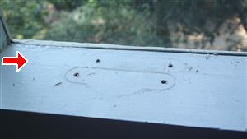
2.2 Painted Windows
2.3 The deck right side rail is loose and needs to be repaired. The front railing is missing.
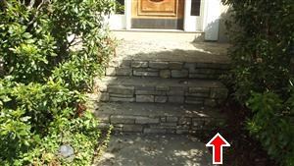
2.3 Front of Home
2.4 The property has overgrown vegetation growing on the left and front of the property
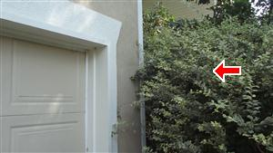
2.4 Vegetation
The exterior of the home was inspected and reported on with the above information. While the inspector makes every effort to find all areas of concern, some areas can go unnoticed. Please be aware that the inspector has your best interest in mind. Any repair items mentioned in this report should be considered before purchase. It is recommended that qualified contractors be used in your further inspection or repair issues as it relates to the comments in this inspection report.
Home Inspection Report Authorized For Neighborhood Assistance Corporation of America (NACA) members only.
Top Table of Contents Bottom

3. Garage
IN NI NP RR  3.0 GARAGE CEILINGS X  3.1 GARAGE WALLS (INCLUDING FIREWALL SEPARATION) X  3.2 GARAGE FLOOR X  3.3 GARAGE DOOR (S) X  3.4 OCCUPANT DOOR FROM GARAGE TO INSIDE HOME X  3.5 GARAGE DOOR OPERATORS (Report whether or not doors will reverse when met with resistance) X  IN NI NP RR  IN=Inspected, NI=Not Inspected, NP=Not Present, RR=Repair or Replace | Styles & Materials  Garage Door Type:  Two automatic  Garage Door Material:  Fiberglass  Auto-opener Manufacturer:  ALL STAR  Occupant Door Closure (from Garage to inside home):  Self Closing door
Comments:
3.5 Garage Door is in good shape.
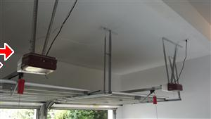
3.5 Garage Door

Top Table of Contents Bottom

4. Interiors
The home inspector shall observe: Walls, ceiling, and floors; Steps, stairways, balconies, and railings; Counters and a representative number of installed cabinets; and A representative number of doors and windows. The home inspector shall: Operate a representative number of windows and interior doors; and Report signs of abnormal or harmful water penetration into the building or signs of abnormal or harmful condensation on building components. The home inspector is not required to observe: Paint, wallpaper, and other finish treatments on the interior walls, ceilings, and floors; Carpeting; or Draperies, blinds, or other window treatments.
IN NI NP RR  4.0 CEILINGS X  4.1 WALLS X  4.2 FLOORS X  4.3 STEPS, STAIRWAYS, BALCONIES AND RAILINGS X  4.4 COUNTERS X  4.5 DOORS (REPRESENTATIVE NUMBER) X  4.6 WINDOWS (REPRESENTATIVE NUMBER) X  IN NI NP RR  IN=Inspected, NI=Not Inspected, NP=Not Present, RR=Repair or Replace | Styles & Materials  Ceiling Materials:  Drywall  Wall Material:  Sheetrock  Floor Covering(s):  Carpet  Hardwood T&G  Interior Doors:  Wood  Window Types:  Double-hung  Window Manufacturer:  UNKNOWN  Cabinetry:  Wood  Countertop:  Laminate
Comments:
4.0 Ceiling Fan is in good working condition.
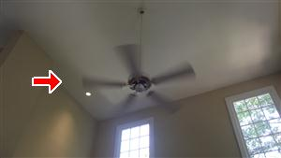
4.0 Ceiling Fan
4.1 Walls are in good condition.
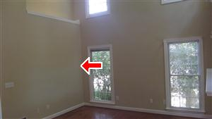
4.1 Interior Wall
4.2 Floors are in good condition.
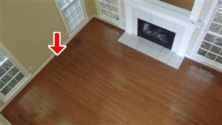
4.2 Interior Floor
4.3 The interior railing on the left side is loose.
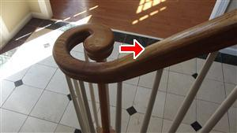
4.3 Loose Railing
4.4 Some of the cabinet doors in the kitchen need to be tightened.
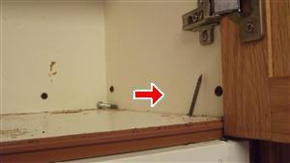
4.4 Damaged Cabinets
4.5 There are four exterior doors on the property.
4.6 There 28 windows on the property, that needs to be opened. The windows will not open due to paint on the windows, some need locks and some are uneven.
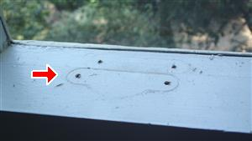
4.6 Missing Locks
The interior of the home was inspected and reported on with the above information. While the inspector makes every effort to find all areas of concern, some areas can go unnoticed. The inspection did not involve moving furniture and inspecting behind furniture, area rugs or areas obstructed from view. Please be aware that the inspector has your best interest in mind. Any repair items mentioned in this report should be considered before purchase. It is recommended that qualified contractors be used in your further inspection or repair issues as it relates to the comments in this inspection report.

Top Table of Contents Bottom

5. Structural Components
The Home Inspector shall observe structural components including foundations, floors, walls, columns or piers, ceilings and roof. The home inspector shall describe the type of Foundation, floor structure, wall structure, columns or piers, ceiling structure, roof structure. The home inspector shall: Probe structural components where deterioration is suspected; Enter under floor crawl spaces, basements, and attic spaces except when access is obstructed, when entry could damage the property, or when dangerous or adverse situations are suspected; Report the methods used to observe under floor crawl spaces and attics; and Report signs of abnormal or harmful water penetration into the building or signs of abnormal or harmful condensation on building components. The home inspector is not required to: Enter any area or perform any procedure that may damage the property or its components or be dangerous to or adversely effect the health of the home inspector or other persons.
IN NI NP RR  5.0 FOUNDATIONS, BASEMENTS AND CRAWLSPACES (Report signs of abnormal or harmful water penetration into the building or signs of abnormal or harmful condensation on building components.) X  5.1 WALLS (Structural) X  5.2 COLUMNS OR PIERS X  5.3 FLOORS (Structural) X  5.4 CEILINGS (structural) X  5.5 ROOF STRUCTURE AND ATTIC X  IN NI NP RR  IN=Inspected, NI=Not Inspected, NP=Not Present, RR=Repair or Replace | Styles & Materials  Foundation:  Masonry block  Method used to observe Crawlspace:  No crawlspace  Floor Structure:  Not visible  Wall Structure:  Wood  Columns or Piers:  Wood piers  Ceiling Structure:  2X8  Roof Structure:  2 X 8 Rafters  Roof-Type:  Gable  Method used to observe attic:  Walked  Attic info:  Pull Down stairs
Comments:
5.5 The property has a partial basement that is finished
The structure of the home was inspected and reported on with the above information. While the inspector makes every effort to find all areas of concern, some areas can go unnoticed. Please be aware that the inspector has your best interest in mind. Any repair items mentioned in this report should be considered before purchase. It is recommended that qualified contractors be used in your further inspection or repair issues as it relates to the comments in this inspection report.

Top Table of Contents Bottom

6. Plumbing System
The home inspector shall observe: Interior water supply and distribution system, including: piping materials, supports, and insulation; fixtures and faucets; functional flow; leaks; and cross connections; Interior drain, waste, and vent system, including: traps; drain, waste, and vent piping; piping supports and pipe insulation; leaks; and functional drainage; Hot water systems including: water heating equipment; normal operating controls; automatic safety controls; and chimneys, flues, and vents; Fuel storage and distribution systems including: interior fuel storage equipment, supply piping, venting, and supports; leaks; and Sump pumps. The home inspector shall describe: Water supply and distribution piping materials; Drain, waste, and vent piping materials; Water heating equipment; and Location of main water supply shutoff device. The home inspector shall operate all plumbing fixtures, including their faucets and all exterior faucets attached to the house, except where the flow end of the faucet is connected to an appliance. The home inspector is not required to: State the effectiveness of anti-siphon devices; Determine whether water supply and waste disposal systems are public or private; Operate automatic safety controls; Operate any valve except water closet flush valves, fixture faucets, and hose faucets; Observe: Water conditioning systems; Fire and lawn sprinkler systems; On-site water supply quantity and quality; On-site waste disposal systems; Foundation irrigation systems; Spas, except as to functional flow and functional drainage; Swimming pools; Solar water heating equipment; or Observe the system for proper sizing, design, or use of proper materials.

IN NI NP RR  6.0 PLUMBING DRAIN, WASTE AND VENT SYSTEMS X  6.1 PLUMBING WATER SUPPLY AND DISTRIBUTION SYSTEMS AND FIXTURES X  6.2 HOT WATER SYSTEMS, CONTROLS, CHIMNEYS, FLUES AND VENTS X  6.3 MAIN WATER SHUT-OFF DEVICE (Describe location) X  6.4 FUEL STORAGE AND DISTRIBUTION SYSTEMS (Interior fuel storage, piping, venting, supports, leaks) X  6.5 MAIN FUEL SHUT OFF (Describe Location) X  IN NI NP RR  IN=Inspected, NI=Not Inspected, NP=Not Present, RR=Repair or Replace | Styles & Materials  Water Source:  Public  Plumbing Water Supply (into home):  CPVC  Plumbing Water Distribution (inside home):  CPVC  Washer Drain Size:  Not visible  Plumbing Wastelines:  PVC  Waste Disposal method:  Public waste system  Water Heater Power Source:  Gas (quick recovery)  Water Heater Capacity:  40 Gallon (1-2 people)  Estimated age of water heater:  > 20 years  Water Heater Location:  Basement  Water Heater Manufacturer:  UNKNOWN
Comments:

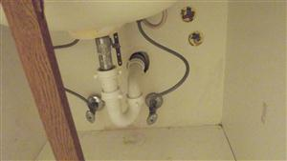
6.0 Bathroom Sink
6.1 The fixtures in the kitchen sink, washroom sink, and the CPVC pipe in the basement bathroom has a leak that needs to be sealed.
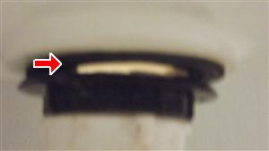  6.1 Broken Seal | 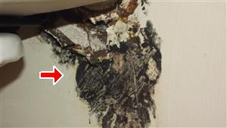  6.1 Water Leaking from Pipe

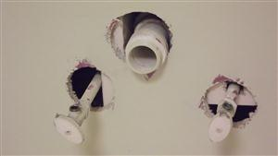
6.1 Plumbing openings needs to sealed.

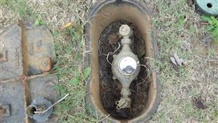
6.3 Picture 1 Water Valve

The plumbing in the home was inspected and reported on with the above information. While the inspector makes every effort to find all areas of concern, some areas can go unnoticed. Washing machine drain line for example cannot be checked for leaks or the ability to handle the volume during drain cycle. Older homes with galvanized supply lines or cast iron drain lines can be obstructed and barely working during an inspection but then fails under heavy use. If the water is turned off or not used for periods of time (like a vacant home waiting for closing) rust or deposits within the pipes can further clog the piping system. Please be aware that the inspector has your best interest in mind. Any repair items mentioned in this report should be considered before purchase. It is recommended that qualified contractors be used in your further inspection or repair issues as it relates to the comments in this inspection report.

Top Table of Contents Bottom

7. Electrical System
The home inspector shall observe: Service entrance conductors; Service equipment, grounding equipment, main over current device, and main and distribution panels; Amperage and voltage ratings of the service; Branch circuit conductors, their over current devices, and the compatibility of their ampacities and voltages; The operation of a representative number of installed ceiling fans, lighting fixtures, switches and receptacles located inside the house, garage, and on the dwelling's exterior walls; The polarity and grounding of all receptacles within six feet of interior plumbing fixtures, and all receptacles in the garage or carport, and on the exterior of inspected structures; The operation of ground fault circuit interrupters; and Smoke detectors. The home inspector shall describe: Service amperage and voltage; Service entry conductor materials; Service type as being overhead or underground; and Location of main and distribution panels. The home inspector shall report any observed aluminum branch circuit wiring. The home inspector shall report on presence or absence of smoke detectors, and operate their test function, if accessible, except when detectors are part of a central system. The home inspector is not required to: Insert any tool, probe, or testing device inside the panels; Test or operate any over current device except ground fault circuit interrupters; Dismantle any electrical device or control other than to remove the covers of the main and auxiliary distribution panels; or Observe: Low voltage systems; Security system devices, heat detectors, or carbon monoxide detectors; Telephone, security, cable TV, intercoms, or other ancillary wiring that is not a part of the primary electrical distribution system; or Built-in vacuum equipment.
IN NI NP RR  7.0 SERVICE ENTRANCE CONDUCTORS X  7.1 SERVICE AND GROUNDING EQUIPMENT, MAIN OVERCURRENT DEVICE, MAIN AND DISTRIBUTION PANELS X  7.2 BRANCH CIRCUIT CONDUCTORS, OVERCURRENT DEVICES AND COMPATIBILITY OF THEIR AMPERAGE AND VOLTAGE X  7.3 CONNECTED DEVICES AND FIXTURES (Observed from a representative number operation of ceiling fans, lighting fixtures, switches and receptacles located inside the house, garage, and on the dwelling's exterior walls) X  7.4 POLARITY AND GROUNDING OF RECEPTACLES WITHIN 6 FEET OF INTERIOR PLUMBING FIXTURES, AND ALL RECEPTACLES IN GARAGE, CARPORT, EXTERIOR WALLS OF INSPECTED STRUCTURE X  7.5 OPERATION OF GFCI (GROUND FAULT CIRCUIT INTERRUPTERS) X  7.6 OPERATION OF ARC FAULT CIRCUIT INTERRUPTERS (AFCI) X  7.7 LOCATION OF MAIN AND DISTRIBUTION PANELS X  7.8 SMOKE DETECTORS X X  7.9 CARBON MONOXIDE DETECTORS X  IN NI NP RR  IN=Inspected, NI=Not Inspected, NP=Not Present, RR=Repair or Replace | Styles & Materials  Electrical Service Conductors:  Panel capacity:  Panel grounded ?:  Panel Type:  Electric Panel Manufacturer:  Branch wire 15 and 20 AMP:  Wiring Methods:  Carbon Monoxide Detectors:  Smoke Detectors:
Comments:
7.3 There are three fans in the interior.
7.7 The main panels has a open port that need to covered
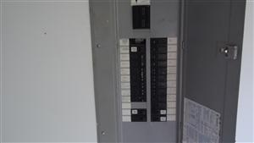  7.7 Breaker Box | 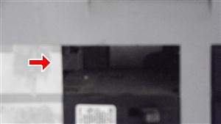  7.7 Missing breaker port
7.8 Smoke Detectors need repair.
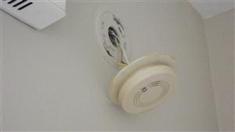
7.8 Smoke Detector
7.9 The property needs three carbon monoxide detectors
The electrical system of the home was inspected and reported on with the above information. While the inspector makes every effort to find all areas of concern, some areas can go unnoticed. Outlets were not removed and the inspection was only visual. Any outlet not accessible (behind the refrigerator for example) was not inspected or accessible. Please be aware that the inspector has your best interest in mind. Any repair items mentioned in this report should be considered before purchase. It is recommended that qualified contractors be used in your further inspection or repair issues as it relates to the comments in this inspection report.

Top Table of Contents Bottom

8. Heating / Central Air Conditioning
The home inspector shall observe permanently installed heating and cooling systems including: Heating equipment; Cooling Equipment that is central to home; Normal operating controls; Automatic safety controls; Chimneys, flues, and vents, where readily visible; Solid fuel heating devices; Heat distribution systems including fans, pumps, ducts and piping, with supports, insulation, air filters, registers, radiators, fan coil units, convectors; and the presence of an installed heat source in each room. The home inspector shall describe: Energy source; and Heating equipment and distribution type. The home inspector shall operate the systems using normal operating controls. The home inspector shall open readily openable access panels provided by the manufacturer or installer for routine homeowner maintenance. The home inspector is not required to: Operate heating systems when weather conditions or other circumstances may cause equipment damage; Operate automatic safety controls; Ignite or extinguish solid fuel fires; or Observe: The interior of flues; Fireplace insert flue connections; Humidifiers; Electronic air filters; or The uniformity or adequacy of heat supply to the various rooms.

IN NI NP RR  8.0 HEATING EQUIPMENT X  8.1 NORMAL OPERATING CONTROLS X  8.2 AUTOMATIC SAFETY CONTROLS X  8.3 DISTRIBUTION SYSTEMS (including fans, pumps, ducts and piping, with supports, insulation, air filters, registers, radiators, fan coil units and convectors) X  8.4 PRESENCE OF INSTALLED HEAT SOURCE IN EACH ROOM X  8.5 CHIMNEYS, FLUES AND VENTS (for fireplaces, gas water heaters or heat systems) X  8.6 SOLID FUEL HEATING DEVICES (Fireplaces, Woodstove) X  8.7 GAS/LP FIRELOGS AND FIREPLACES X  8.8 COOLING AND AIR HANDLER EQUIPMENT X  8.9 NORMAL OPERATING CONTROLS X  8.10 PRESENCE OF INSTALLED COOLING SOURCE IN EACH ROOM X  IN NI NP RR  IN=Inspected, NI=Not Inspected, NP=Not Present, RR=Repair or Replace | Styles & Materials  Heat Type:  Estimated age of Heat System:  Energy source of Heat System:  Number of Heat Systems (excluding wood):  Heat System Brand:  Ductwork:  Filter Type:  Filter Size:  Types of Fireplaces:  Operable Fireplaces:  Number of Woodstoves:  Cooling Equipment Type:  Estimated age of central AC:  Cooling Equipment Energy Source:  Central Air Manufacturer:  Number of AC Only Units:
Comments:
8.0
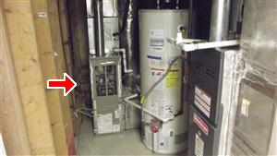
8.0 HVAC 1

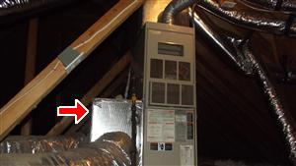
8.3 HVAC 2
The heating and cooling system of this home was inspected and reported on with the above information. While the inspector makes every effort to find all areas of concern, some areas can go unnoticed. The inspection is not meant to be technically exhaustive. The inspection does not involve removal and inspection behind service door or dismantling that would otherwise reveal something only a licensed heat contractor would discover. Please be aware that the inspector has your best interest in mind. Any repair items mentioned in this report should be considered before purchase. It is recommended that qualified contractors be used in your further inspection or repair issues as it relates to the comments in this inspection report.

Top Table of Contents Bottom

9. Insulation and Ventilation
The home inspector shall observe: Insulation and vapor retarders in unfinished spaces; Ventilation of attics and foundation areas; Kitchen, bathroom, and laundry venting systems; and the operation of any readily accessible attic ventilation fan, and, when temperature permits, the operation of any readily accessible thermostatic control. The home inspector shall describe: Insulation in unfinished spaces; and Absence of insulation in unfinished space at conditioned surfaces. The home inspector shall: Move insulation where readily visible evidence indicates the need to do so; and Move insulation where chimneys penetrate roofs, where plumbing drain/waste pipes penetrate floors, adjacent to earth filled stoops or porches, and at exterior doors. The home inspector is not required to report on: Concealed insulation and vapor retarders; or Venting equipment that is integral with household appliances.
IN NI NP RR  9.0 INSULATION IN ATTIC X  9.1 INSULATION UNDER FLOOR SYSTEM X  9.2 VAPOR RETARDERS (ON GROUND IN CRAWLSPACE OR BASEMENT) X  9.3 VENTILATION OF ATTIC AND FOUNDATION AREAS X  9.4 VENTING SYSTEMS (Kitchens, baths and laundry) X  9.5 VENTILATION FANS AND THERMOSTATIC CONTROLS (ATTIC) X  IN NI NP RR  IN=Inspected, NI=Not Inspected, NP=Not Present, RR=Repair or Replace | Styles & Materials  Attic Insulation:  Roof Ventilation:  Exhaust Fans:  Dryer Power Source:  Dryer Vent:  Floor System Insulation:
Comments:
9.0 The insulation in the attic is below 36 inches on the right.
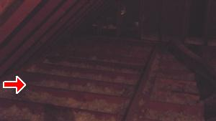
9.0 Low Insulation
9.3
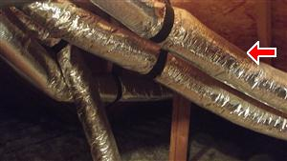
9.3 Duct System
The insulation and ventilation of the home was inspected and reported on with the above information. While the inspector makes every effort to find all areas of concern, some areas can go unnoticed. Venting of exhaust fans or clothes dryer cannot be fully inspected and bends or obstructions can occur without being accessible or visible (behind wall and ceiling coverings). Only insulation that is visible was inspected. Please be aware that the inspector has your best interest in mind. Any repair items mentioned in this report should be considered before purchase. It is recommended that qualified contractors be used in your further inspection or repair issues as it relates to the comments in this inspection report.

Top Table of Contents Bottom

10. Built-In Kitchen Appliances
The home inspector shall observe and operate the basic functions of the following kitchen appliances: Permanently installed dishwasher, through its normal cycle; Range, cook top, and permanently installed oven; Trash compactor; Garbage disposal; Ventilation equipment or range hood; and Permanently installed microwave oven. The home inspector is not required to observe: Clocks, timers, self-cleaning oven function, or thermostats for calibration or automatic operation; Non built-in appliances; or Refrigeration units. The home inspector is not required to operate: Appliances in use; or Any appliance that is shut down or otherwise inoperable.
IN NI NP RR  10.0 DISHWASHER X  10.1 RANGES/OVENS/COOKTOPS X  10.2 RANGE HOOD X  10.3 TRASH COMPACTOR X  10.4 FOOD WASTE DISPOSER X  10.5 MICROWAVE COOKING EQUIPMENT X  IN NI NP RR  IN=Inspected, NI=Not Inspected, NP=Not Present, RR=Repair or Replace | Styles & Materials  Dishwasher Brand:  Estimated age of Dishwasher:  Disposer Brand:  Estimated age of Disposer:  Exhaust/Range hood:  Range/Oven:  Energy source for Range/Oven:  Estimated age of Range/Oven:  Built in Microwave:  Estimated age of built in Microwave:  Trash Compactors:  Estimated age of Trash Compactor:

Comments:
10.0 The dishwasher needs to be replaced.
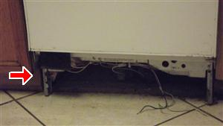
10.0 Dishwasher
10.1 The stove needs to be cleaned, and the broken knobs need to be replaced.
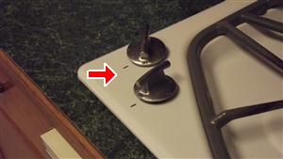

10.2 The range hood is not working, needs to be replaced.
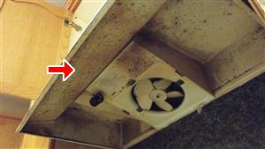
10.2 Picture 1 Broken Range Hood

10.4 The garbage disposal is missing and needs to be replaced.
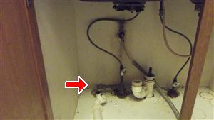
10.4 Garage Disposal

The built-in appliances of the home were inspected and reported on with the above information. While the inspector makes every effort to find all areas of concern, some areas can go unnoticed. Please be aware that the inspector has your best interest in mind. Any repair items mentioned in this report should be considered before purchase. It is recommended that qualified contractors be used in your further inspection or repair issues as it relates to the comments in this inspection report.

Top Table of Contents Bottom

11. Photo Library
11.0 | Exterior view (Front and Back)
11.1 | Living Room view
11.2 | Kitchen view
11.3 | Dining room view
11.4 | Other rooms view(s)

Comments:
11.0 Inspection photo view of Exterior.
11.0 Front | 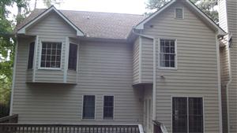  11.0 Rear
11.1 Inspection photo view of Living Room
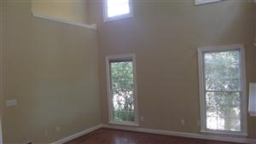
11.1 Living Room

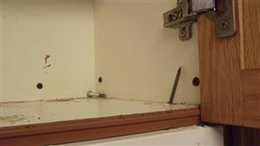
11.2 Kitchen Cabinet
11.3 Inspection photo view of Dining room.
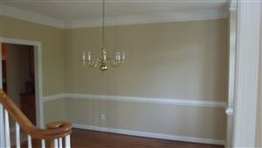
11.3 Dining Room
11.4
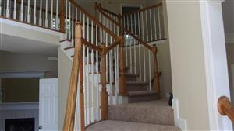  11.4 Stairwell | 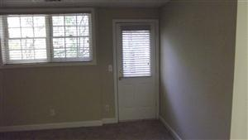  11.4 Basement

Top Table of Contents Bottom

General Summary

Agape Inspection Management Service Inc.
1-800-681-2467
Customer
Address
The following items or discoveries indicate that these systems or components do not function as intended or adversely affects the habitability of the dwelling; or warrants further investigation by a specialist, or requires subsequent observation. This summary shall not contain recommendations for routine upkeep of a system or component to keep it in proper functioning condition or recommendations to upgrade or enhance the function or efficiency of the home. This Summary is not the entire report. The complete report may include additional information of concern to the customer. It is recommended that the customer read the complete report.

1. Roofing
1.3 | ROOF DRAINAGE SYSTEMS
 | Repair or Replace | Detailed quotation required.
The right upper downspout is missing.
1.3 Missing Downspout

2. Exterior
2.2 | WINDOWS
 | Repair or Replace | Detailed quotation required.
The windows in the property are shut tight and can not open due to to paint.
2.2 Painted Windows

2.3 | DECKS, BALCONIES, STOOPS, STEPS, AREAWAYS, PORCHES, PATIO/ COVER AND APPLICABLE RAILINGS
 | Repair or Replace | Detailed quotation required.
The deck right side rail is loose and needs to be repaired. The front railing is missing.
2.3 Front of Home

2.4 | VEGETATION, GRADING, DRAINAGE, DRIVEWAYS, PATIO FLOOR, WALKWAYS AND RETAINING WALLS (With respect to their effect on the condition of the building)
 | Repair or Replace | Detailed quotation required.
The property has overgrown vegetation growing on the left and front of the property
2.4 Vegetation

4. Interiors
4.3 | STEPS, STAIRWAYS, BALCONIES AND RAILINGS
 | Repair or Replace | Detailed quotation required.
The interior railing on the left side is loose.
4.3 Loose Railing

4.4 | COUNTERS AND A REPRESENTATIVE NUMBER OF CABINETS
 | Repair or Replace | Detailed quotation required.
Some of the cabinet doors in the kitchen need to be tighten
4.4 Damaged Cabinets

4.6 | WINDOWS
 | Repair or Replace | Detailed quotation required.
There 28 windows on the property, that need to be opened. The windows will not open due to paint on the windows, some need locks and some are uneven.
4.6 Missing Locks

6. Plumbing System
6.1 | PLUMBING WATER SUPPLY AND DISTRIBUTION SYSTEMS AND FIXTURES
 | Repair or Replace | Detailed quotation required.
The fixtures in the kitchen sink, washroom sink, and the cpvc pipe in the basement bathroom has a leak that need to be sealed
6.1Broken Seal | 6.1 Water Leaking from Pipe

6.1 Pipe Openings Need Seals

7. Electrical System
7.0 | SERVICE ENTRANCE CONDUCTORS
 | Inspected

7.7 | LOCATION OF MAIN AND DISTRIBUTION PANELS
 | Repair or Replace | Detailed quotation required.
The main panels has a open port that need to covered
7.7 Breaker Box | 7.7 Missing breaker port

7.8 | SMOKE DETECTORS
 | Inspected, Repair or Replace | Detailed quotation required.
Smoke Detectors need repair.
7.8 Picture 1 Smoke Detector

7.9 | CARBON MONOXIDE DETECTORS
 | Not Present | Detailed quotation required.
 | The property needs three carbon monoxide detectors

9. Insulation and Ventilation
9.0 | INSULATION IN ATTIC
 | Repair or Replace | Detailed quotation required.
The insulation in the attic is below 36 inches on the right.
9.0 Low Insulation

10. Built-In Kitchen Appliances

10.0 | DISHWASHER
 | Repair or Replace | Detailed quotation required.
The dishwasher needs to be replaced.
10.0 Dishwasher

10.1 | RANGES/OVENS/COOKTOPS
 | Repair or Replace | Detailed quotation required.
The stove needs to be cleaned, and the broken knobs need to be replaced.
10.1 Broken Stove Knobs/Dirt

10.2 | RANGE HOOD
 | Repair or Replace | Detailed quotation required.
The range hood is not working, needs to be replaced.
10.2 Broken Range Hood

10.5 | MICROWAVE COOKING EQUIPMENT
 | Not Present

Home inspectors are not required to report on the following: Life expectancy of any component or system; The causes of the need for a repair; The methods, materials, and costs of corrections; The suitability of the property for any specialized use; Compliance or non-compliance with codes, ordinances, statutes, regulatory requirements or restrictions; The market value of the property or its marketability; The advisability or inadvisability of purchase of the property; Any component or system that was not observed; The presence or absence of pests such as wood damaging organisms, rodents, or insects; or Cosmetic items, underground items, or items not permanently installed. Home inspectors are not required to: Offer warranties or guarantees of any kind; Calculate the strength, adequacy, or efficiency of any system or component; Enter any area or perform any procedure that may damage the property or its components or be dangerous to the home inspector or other persons; Operate any system or component that is shut down or otherwise inoperable; Operate any system or component that does not respond to normal operating controls; Disturb insulation, move personal items, panels, furniture, equipment, plant life, soil, snow, ice, or debris that obstructs access or visibility; Determine the presence or absence of any suspected adverse environmental condition or hazardous substance, including but not limited to mold, toxins, carcinogens, noise, contaminants in the building or in soil, water, and air; Determine the effectiveness of any system installed to control or remove suspected hazardous substances; Predict future condition, including but not limited to failure of components; Since this report is provided for the specific benefit of the customer(s), secondary readers of this information should hire a licensed inspector to perform an inspection to meet their specific needs and to obtain current information concerning this property.

Top Table of Contents Bottom

INVOICE

Agape Inspection Management Service  Decatur, GA 30033  1-800-681-2467  Inspected By: Darnell Harrington | Inspection Date: 9/22/2012  Report ID: 4051899

Customer Info: | Inspection Property:
Customer's Real Estate Professional:
Inspection Fee:
Service | Price | Amount | Sub-Total
$275.00
Tax $0.00
Total Price $275.00
Payment Method: Cash
Payment Status: Paid
Note:
Top Table of Contents Bottom

Inspection Agreement
This inspection was performed in accordance with and under the terms of a Pre-Inspection Agreement. The agreement was signed and agreed upon before the preparation of this report and a signed copy of the agreement is available upon request. An unsigned copy of the agreement may be attached to this report for your information or it may also be available on the home inspection company web site.
Top Table of Contents Bottom
